Title of Manuscript (Format: Centered, Title Case, Times New Roman, 14 pt)

Full Name¹, Corresponding Author^{1,}, Author² (All Authors names must be written in a FULL NAME; Format: Centered, Times New Roman, 11 pt)

¹ Department, Faculty, Institute, City/ State, Country (Format: Align left, Times New Roman, 10 pt, Italic)
² Department, Faculty, Institute, City/ State, Country
* Corresponding author: e-mail address here

Abstract
All articles must contain an abstract. Content in abstract should be written with the Font style: Times New Roman; Font size: 10; Paragraph: Justify; Line spacing: 1.0. Insert two spacing after the abstract before you begin the main text of your article, starting on the same page as the abstract. The abstract should give readers concise information about the content of the article and indicate a short introduction of background study, purpose of the study, briefing about the used method, principal results and major conclusions. The abstract is not part of the text and should be complete in itself; no table numbers, figure numbers, references or displayed mathematical expressions should be included. It should be suitable for direct inclusion in abstracting services and should not exceed 250 words in a single paragraph. Since contemporary information-retrieval systems rely heavily on the content of titles and abstracts to identify relevant articles in literature searches, great care should be taken in constructing both.

Keywords: Keyword 1; Keyword 2; Keyword 3; Keyword 4; Keyword 5 (maximum no. of keywords: 5)

Introduction (Format: Centered, Title Case, Times New Roman, 10 pt)

Leave one blank line space below the section header before starting the text. The first paragraph after a heading must not be indented. All body text should adhere to the following formatting:
- Font: Times New Roman, 10 pt
- Alignment: Justified
- Line Spacing: Single (1.0)
- Spacing Between Paragraphs: Leave one blank line space.
- Indentation: Subsequent paragraphs must be indented by 0.63 cm.

In Introduction, Authors must clearly highlight the research gap and the significance of the study before stating the research objectives. These three elements are very important and compulsory.

Other Main Sections

The paragraph formatting rules above apply to all sections of the manuscript (no indent for the first paragraph, 0.63 cm indent for subsequent paragraphs). Authors should ensure the extended abstract covers the core components of the research, including but not limited to:
- Introduction
- Methodology
- Results and Discussion
- Conclusion

Figure and Table Style and Format

All figures and tables must be centered, numbered consecutively (e.g., Figure 1, Table 1), and placed immediately after the paragraph where they are first discussed. Leave one blank line before and after each figure or table.

Caption & Title Formatting (For Both):
- Font: Times New Roman 10 pt.
- Punctuation: Do NOT put a full stop (period) at the end of a figure caption or table title.

Figures:
- Quality: Must be high-resolution, clear, and readable.
- Captions: Place the caption below the figure.
- In-text Citations: Always spell out the word "Figure" in the text (e.g., "Figure 1"). Do not abbreviate as "Fig. 1".

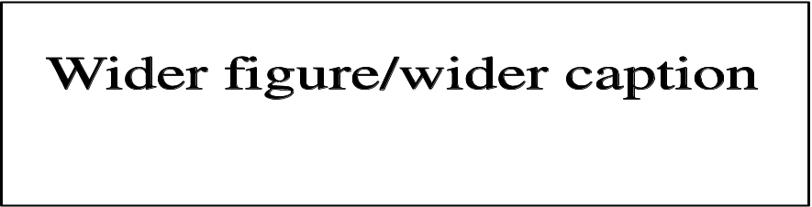
Figure 1 Figure with short caption (caption centred)

Figure 2 Figure with long caption (justify the caption so that it is as the same width as the graphic)

Tables:
- Titles: Place the title above the table, set to the width of the table.
- Content: Text inside the table should be left-aligned. (Times New Roman 9 pt).

Table 1 Place the caption above the table
Distance (m) | Velocity (ms^{–1})
A | 1
B | 2
D | 4

Equation Style and Format

All equations mentioned in the text must be numbered consecutively. Please adhere to the following guidelines:
- Tool: Use the Microsoft Word Equation tool to insert all equations.
- Font Size: 10 pt.
- In-text Citations: Always spell out the word "Equation" in the text (e.g., "As shown in Equation 1..."). Do not abbreviate as "Eq. 1".

$y=mx+c$ (1)

Acknowledgement
Authors should list all the funding sources in the Acknowledgments section. Authors are responsible for the accuracy of their funder designation. (Note: This part is compulsory. If this research was not funded by any grant, please write 'This research was not funded by any grant.')

References
The list of references should only include works that are cited in the text and that have been published or accepted for publication. Personal communications and unpublished works should only be mentioned in the text. Reference style should be in APA style. Citation of the references should be write using author name system (Rosly et al., 2020).

Rosly, M. B., Jusoh, N., Othman, N., Rahman, H. A., Sulaiman, R. N. R., & Noah, N. F. M. (2020). Stability of emulsion liquid membrane using bifunctional diluent and blended non-ionic surfactant for phenol removal. Chemical Engineering and Processing, 148, 107790. https://doi.org/10.1016/j.cep.2019.107790

